Conservation Corps Minnesota Clean Water Project
Carlton SWCD Riparian Forest Buffer Establishment, Elim Creek
Elim Creek is in the Skunk Creek Watershed, which is a tributary of the turbidity impaired North Fork of the Nemadji River. In 2011, Clean Water Fund - Clean Water Assistance funds were awarded to Carlton SWCD to complete a comprehensive dam removal project on Elim Creek, a designated trout stream. The project involved three structures in a series within the 1/3 mile section of creek. The furthest downstream structure had failed, causing 304 tons of sediment to be flushed into the watershed and the two upstream structures had rusted principle pipe spillways making failure a serious threat. This failure would result in an estimated additional soil loss of 956 tons.
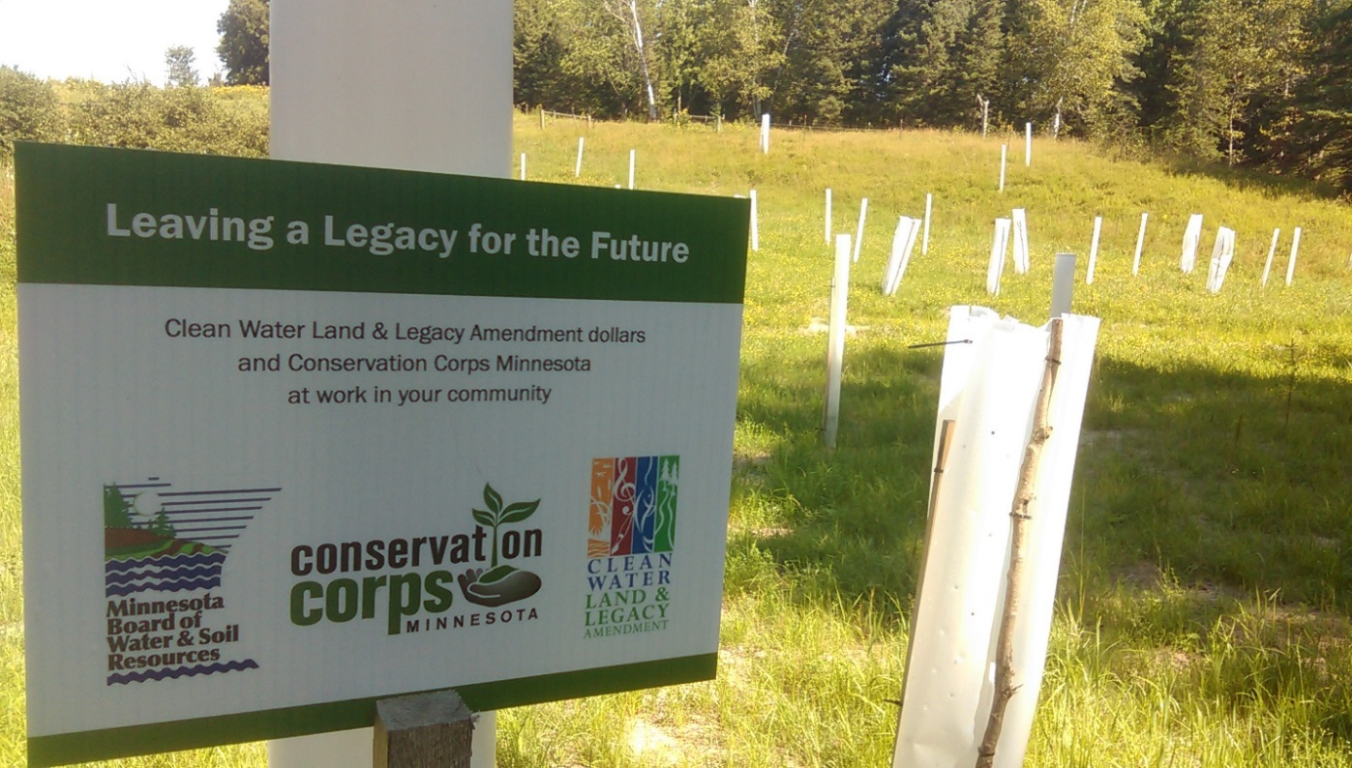
The Clean Water Funded Elim Creek Riparian Forest Buffer Project reduced the threat of 1260 tons of sediment loading by removing failing structures and restoring a natural geomorphic stream channel to Elim Creek. Funded by Clean Water Funds, Conservation Corps Minnesota crews partnered with Carlton SWCD to establish a 321,487 square foot riparian forest buffer strip, install 150 feet of cattle exclusion fencing and plant 1800 trees along Elim Creek in fall 2014.

Pine River Journal Article – May 28, 2015

